Is ESG Good for Everyone in the World?
Thông tin:
Mục này bao gồm nội dung chưa được dịch sang ngôn ngữ ưa thích của bạn.
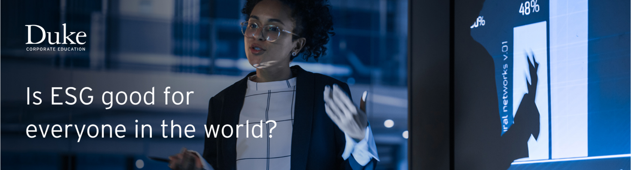
More opposing arguments to ESG are related to the climate transition of developing countries. However, it's vital for developing countries to prioritize the climate transition process as it can lead to several benefits.
Climate Finance
Climate finance refers to local, national or transnational financing aimed at supporting mitigation and adaptation actions that will address climate change.
Can you guess how many billions of dollars have been agreed to finance the transition of developing countries through the Paris Agreement?
At COP15 in 2009, developed countries committed to a collective goal of mobilizing USD 100 billion per year by 2020 to support climate action in developing countries.
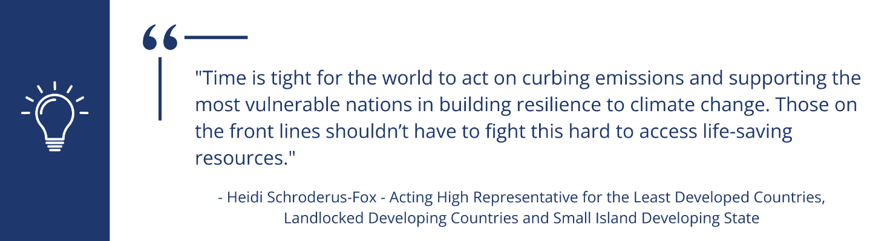"Time is tight for the world to act on curbing emissions and supporting the most vulnerable nations in building resilience to climate change. Those on the front lines shouldn't have to fight this hard to access life-saving resources." - Heidi Schroderus-Fox - Acting High Representative for the Least Developed Countries, Landlocked Developing Countries and Small Island Developing State
How Would You Engage Others on Climate Finance?
Below is a list of common arguments for the climate transition. Each argument is followed by a "Potential Doubt," representing a key challenge or hesitation associated with climate action, especially from a developing country's perspective. Review this list and reflect on how you would help engage others on climate finance.
List of Arguments | Potential Doubt
"By committing to the climate transition, developing countries can access international climate finance support through programs like the Green Climate Fund to carry out sustainable developments projects and invest in low-carbon growth." | Will climate finance programs meet all needs, and how accessible will this funding really be?
"Developing countries are 'entitled' to emit their 'fair share' of GHG to support their development." | Are fossil-fuel resources crucial for short-term economic gains?
"Regulations in developed countries will make it harder for fossil-fuel intensive countries. Developing countries that don't embrace the transition will no longer have access to the rich markets of developed countries." | Is there a risk of being economically isolated or left behind?
"With our poverty rate every job counts, we can't risk closing coal mines for jobless solar panels." | Will the transition exacerbate economic hardship, especially in terms of job losses?
"We should be focusing on alleviating extreme poverty, not on becoming net zero." | Will the focus on climate transition distract from other urgent development priorities?
"Switching to sustainable energy sources can help to reduce air pollution, water pollution, and other environmental health issues caused by fossil fuels, improving quality of life." | Can the health and environmental benefits of transition justify the associated economic costs?
"What if developing countries transition to a green economy while other countries continue to use cheaper, more polluting energy sources?" | Will transitioning to a green economy create a competitive disadvantage internationally?
"A green economy can help to create new jobs, reduce energy dependence and stimulate economic growth by developing innovative technologies to reduce emissions." | Can the Net Zero transition realistically support economic stability and growth?

In Summary
- Developing countries will feel the worst impacts of climate change, so Net Zero transition is a great opportunity.
- Developing countries that do not transition will be left behind, cut out from developed markets (for instance, Scope 3 emissions and Carbon Adjustment Border Mechanism).
- Developing countries have a unique opportunity to leapfrog, with less legacy infrastructure to be adapted, and to avoid building the infrastructure of the past for the future.
Additional Resources
- Carbon Border Adjustment Mechanism (CBAM) (Council of the European Union)
- JETP Just Energy Transition Partnership to Decarbonize South Africa (YouTube Video)
- Net Zero Transition Opportunities (McKinsey Sustainability)

